HONG KONG INSTITUTE OF VOCATIONAL EDUCATION

**AI Workshop: Snake Game by using Teachable machine and p5.js**

**Name:___Chan Tak Keung ____________________ Time Allowed:**  90 min

**Class:_______524122________________ Date:_______27/9/2022______________**

**Procedures**

### A. Create FIVE gestures image samples to control the snake movement

A1. Connect PC webcam to the computer or follow the instructions from MobileWebcam.docx to use your smart phone as the webcam.

A2. Visit the link <https://teachablemachine.withgoogle.com/> using the Chrome browser.

A3. Click the **Get Started** button to create the new project

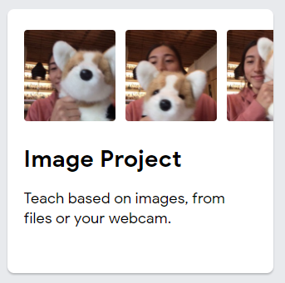A4. Click “Image Project” to create a new image project.

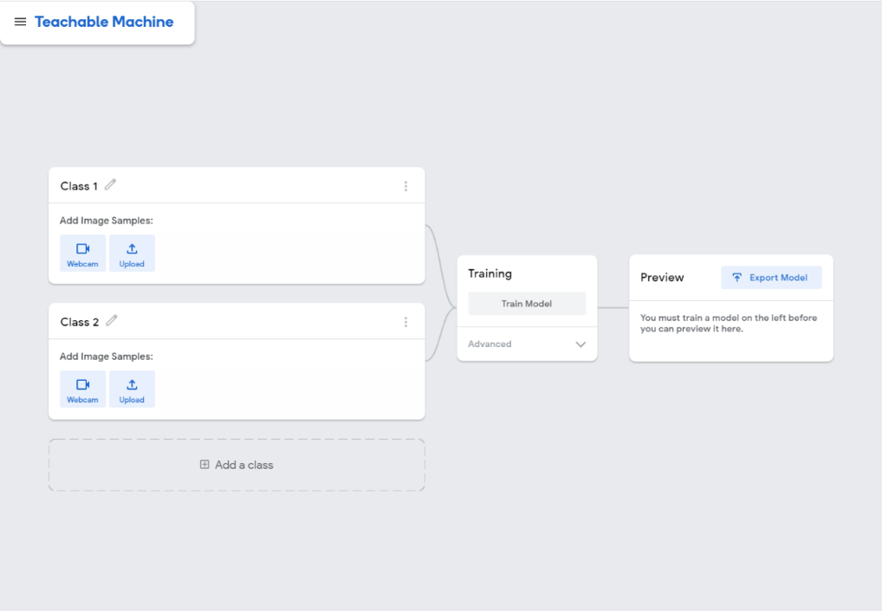 A5. The web browser will open a page for you to create a model.

A6. Change **Class 1** to **Left** in the Image Set Column.

|  |  |
| --- | --- |
| Before | After |
|  |  |

A7. Click **Settings Icon** and change the setting as below.

|  |  |
| --- | --- |
|  | FPS: 24  Hold to Record: OFF  Delay: 2 seconds  Duration: 15 seconds |

A8. Click **Save Settings** at the bottom.

A9. Click “Record 15 Seconds” to record a gesture for controlling the snake to the left as below.

Tips: Try to move your hand in different positions/orientations, it helps to improve the robustness the AI model.

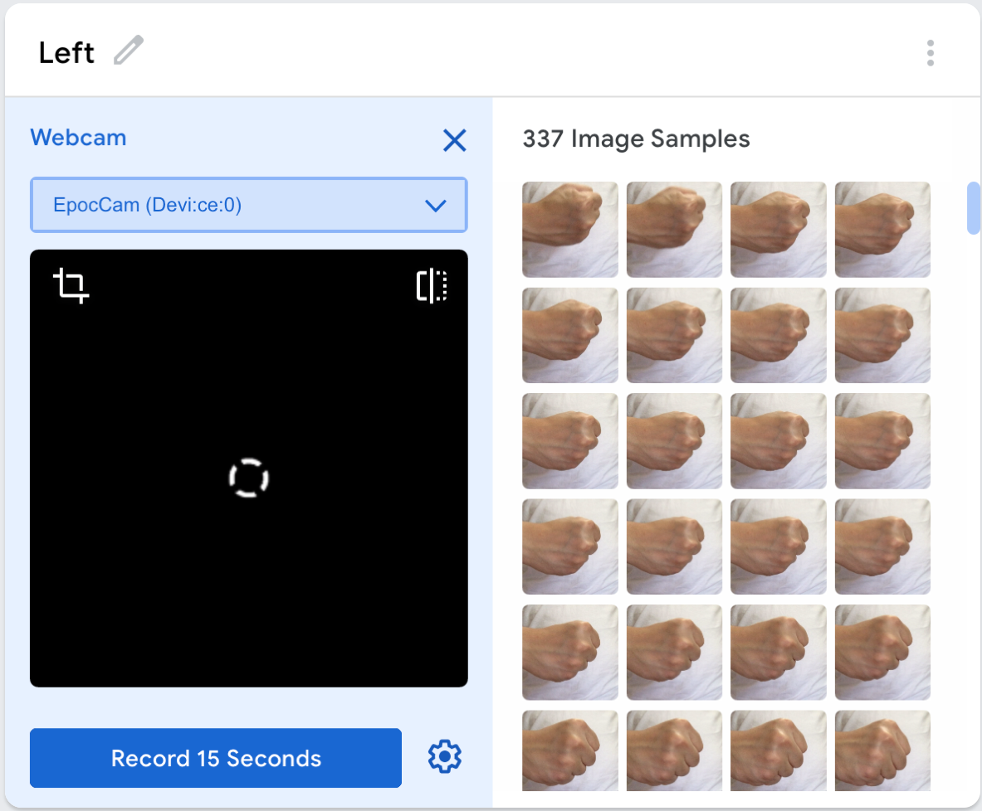

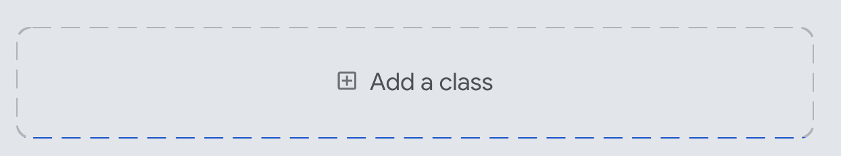A10. Click “**Add a class”** to create another 4 image sets to control the snake movement. (Order is **NOT** important.)

|  |  |
| --- | --- |
| Right | Up |
| ../Right-samples/293.jpg | ../Up-samples/299.jpg |
| Down | Nothing |
| ../Down-samples/274.jpg | ../Nothing-samples/35.jpg |

### B Train your model and testing

B1 Now you can train your model by clicking the **Train Model** button.

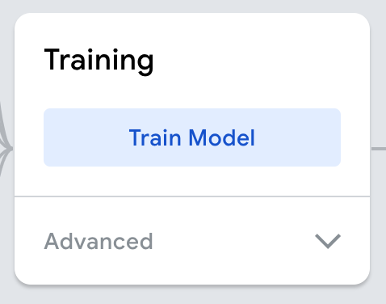

It may need a while… so you can take a break.

But remember don't switch tab or close the browser, you must leave the page open to train your model.

B2 Capture and paste the whole screenshot below. [25%]

|  |
| --- |
| Any one of the Gesture (Left / Right / Up / Down / Nothing) |
|  |

### C Start to create a basic Snake game

C1. Go to the link <https://editor.p5js.org/> to create a new p5js project.

C2. Create an account (optional – if you want to save your project.)

C3. Open the source codes **sketch.js** from the resources folder using Notepad++, copy the source codes **sketch.js** and replace the existing one (sketch.js).

C4. Create a new file **snake.js**

1. Click the buttons below.

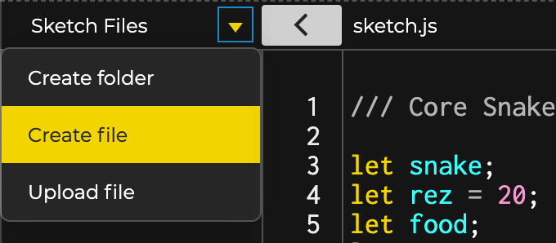

1

2

3

1. Name it as **snake.js**

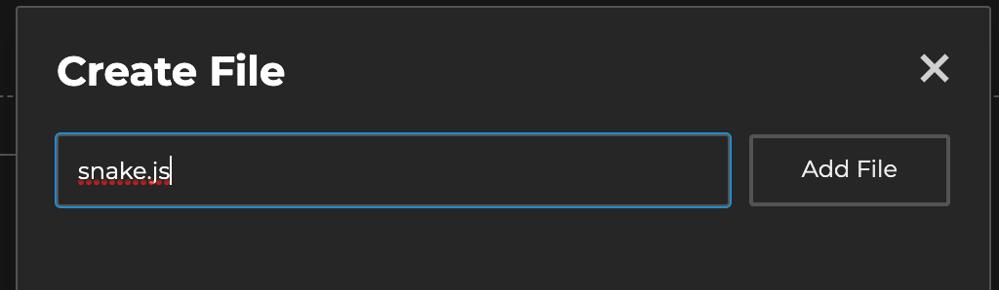

C5. Open the source codes **snake.js** from the resources folder using Notepad++, copy the source codes **snake.js** and replace the existing one (snake.js).

C6. Open the **index.html** from Sketch Files. Copy the following code and add it at (***line 12***) as below. It aims to load the JavaScript “snake.js” into the index page.

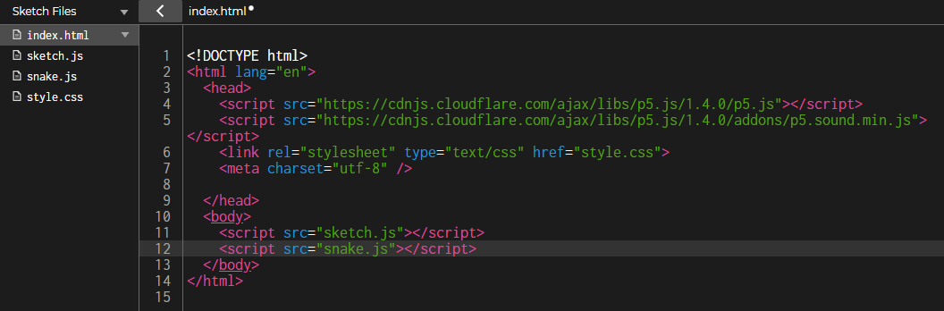

<script src="snake.js"></script>

C7. Copy the following code and add it at (***line 6***) in the index.html file as below.

<script src="https://unpkg.com/ml5@0.4.3/dist/ml5.min.js"></script>

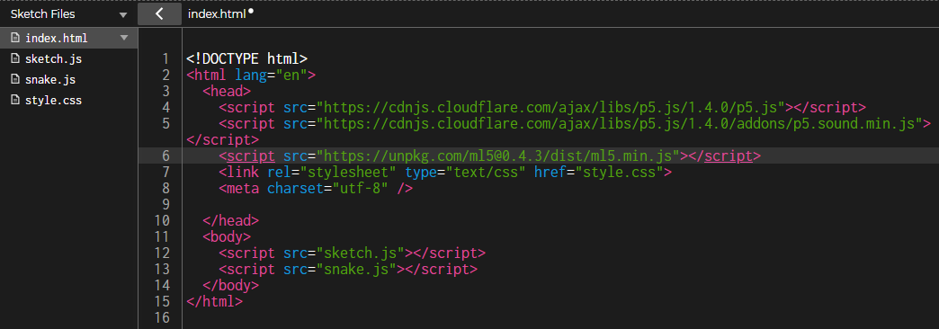

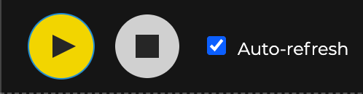C8. Check the **Auto-refresh** and click **Play button.** You can click the Preview screen and use the four arrows ↑ ↓ ← → to control the snake movement.

C9. Capture and paste the Preview below. [10%]

|  |
| --- |
|  |

### D Integrate the hand gestures into the snake game

D1. Goto the page Teachable Machine and click “Export Model”.

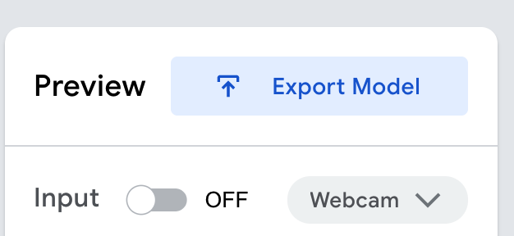

D2. Choose **Tensorflow.js** and click **Upload my model**.

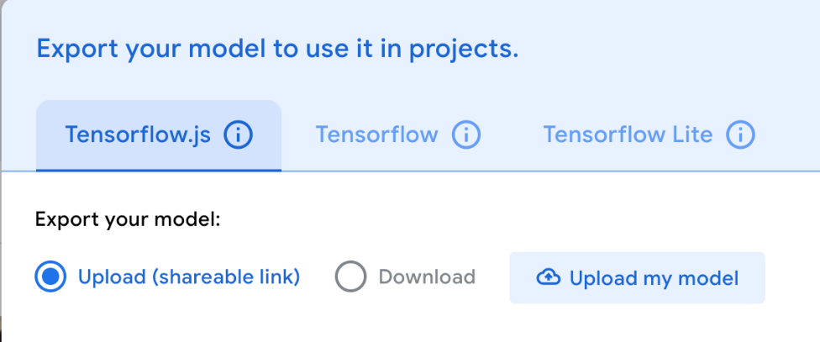

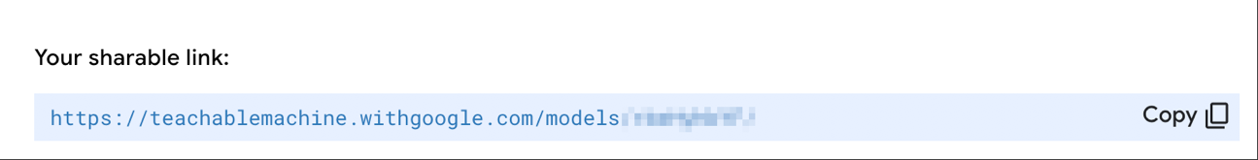D3. Copy “Your sharable link”.

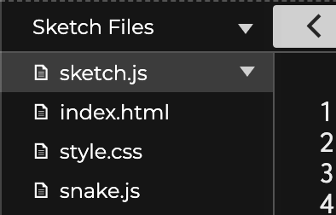D4. Select "sketch.js" file from the Sketch file.

D5. Paste the copied link as below. This is going to apply the classifier that you trained into your snake game.



**\*Note: Remember to keep "/model.json" at the end of the link.**

### E Control the snake with gestures

E1. Find and change the function name "keyPressed" to "controlSnake".

E2. Change LEFT_ARROW, RIGHT_ARROW, DOWN_ARROW, UP_ARROW to "Left", "Right", "Down" and "Up" respectively. You may copy the code below and paste into the (***line 53 to 64***)

// Step E2: Change this function from "keyPressed" to "controlSnake" and the keyCode to label

function controlSnake() {

if (label == "**Left**") {

snake.setDir(-1, 0);

} else if (label == "**Right**") {

snake.setDir(1, 0);

} else if (label == "**Down**") {

snake.setDir(0, 1);

} else if (label == "**Up**") {

snake.setDir(0, -1);

}

}

**HINT**

The text inside quotation (e.g "Left") should same as the Image Set name in Teachable Machine.

**Remember in programming world, all texts are usually case-sensitive.**



|  |  |
| --- | --- |
| Before | After |
|  |  |

E3. Now, goto function "gotResults", add a call function " controlSnake(); " in line 42.

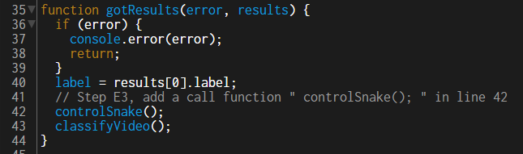

E4. Try to play your game with the gesture that you trained in Teachable Machine. Capture the whole browser in the below box [25%]

|  |
| --- |
|  |

*Note: If you want to see display your cam in the output, you can add “//” to disable the command video.hide();in ***line 20***.

### Short Question

Q1. List THREE types of classification that the Teachable Machine can work with.

[12%]

AI Snake game with boss. Ringfit with boss. Magicshow to boss.

Q2. List THREE factors to improve the robustness of the AI model [18%]

Ringfit can make people do exercise.

AI can make money.

Help people solve problem.

Q3. Give an example where the Teachable Machine can be used in our daily life. [10%]

AI Snake game with boss. Ringfit with boss. Magicshow to boss.

**Submission of the CA Workshop**

This CA Workshop contributes 10% of the module marks.

Submit this CA Workshop (word file) to Moodle.

Deadline: Refer to Moodle

**- END -**